Weight Bench, Abdominal Training Workout Gliding Bench Exercise Gym Training Fitness Incline Adjustable Foldable Dumbbell Barbell Workout Bench - Compact Design
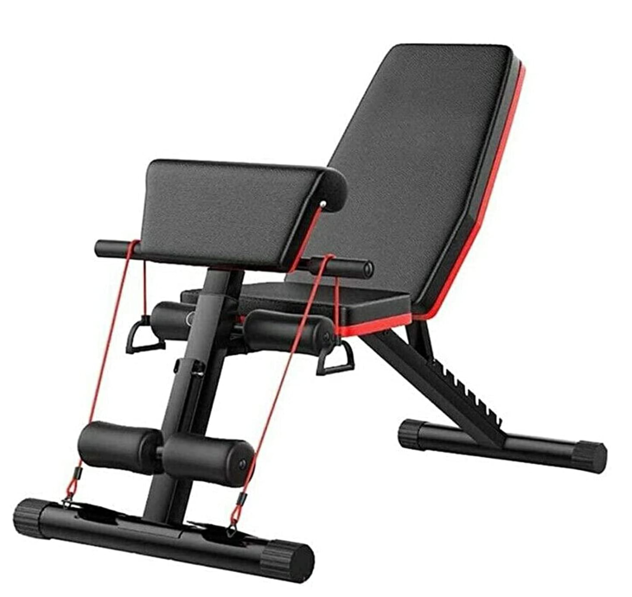

About this item
• Weight Bench, Exercise Gym Training Fitness Incline Adjustable Foldable Dumbbell Barbell Workout Bench - Compact Design
• ALL-PURPOSE BENCH | This fitness and weight bench is an all-in-one base on your journey to physical fitness. Do every exercise in greater comfort with less injury & use its adjustable settings to target specific muscle groups.
• BESPOKE FIT | The foam-padded leg rollers lock at 4 levels to fit your body, and the backrest offers 7 angles between 120 and 200 degrees to focus exercise just where you need it.
• SUPERIOR DURABILITY | The powerful steel frame and 2-inch cotton padding are sheathed in a protective coating and quality artificial leather to provide years of comfortable reliable use for loads up to 150 kilograms.
• RESISTANCE BAND SET | 2 exercise bands come included to allow healthy low-impact cardio and strength training with bodyweight resistance, maximising gains while minimising any chance of injury.
• EASY STORAGE | Our adjustable workout bench folds quickly and easily to 1/5 its normal size to allow easy transport and storage between sessions, letting you save space. Rubber sheaths protect your flooring during and between workouts.

Home Gym Fitness Equipment Adjustable Incline Weight Bench

- Usage Bodybuilding Fitness
- Color As the pictures
- Logo Customized logo
- Carton size 76*32*32cm
- N.W. 10KGS
- G.W. 11KGS
- Product size 130*42*(40-102)cm
- Max user weight 260kgs
- Part number: DB-EX-BENCH

